Pre-Reading

In the Park
The first word we will look at is 自己 (zi4ji3), which means myself contains the first character 自. This is a pictograph of a nose, still to this day some Chinese people point to their nose when referring to themselves, where as Americans tend to point to their chest. The next word we see is 公园 (gong1yuan2), which literally means public garden, or park. The first character 公 the bottom part of this character use to be a mouth (口) and the top part meant that things would be divided for the purpose of consumption (mouth), so this character is supposed to mean fair or equitable, which is what the public sphere should be. The second character 园 has a box around a 元. The box tells us that this is an enclosure, such as most parks are enclosed, and the inside character tells us the sound yuan2. 元 is the character used to represent Chinese money. The next word may be review, but we will look at it again, 漂亮 (piao4liang). The first character 漂 means to float, you can see the three dots on the left side that tell you this character is related to water. The second character means bright, the top part of the character looks like 高 which means tall, and the bottom part looks like 儿, which means child. So this character is a child looking up at a tall bright building. 漂亮together means beautiful, so floating brightness is how the Chinese see beautiful or pretty. The next character is 树, the left side of the character is 木 which means wood and the left side is 对which means right or upright, so an upright piece of wood is a tree. Following this we have the word 颜色, which simply means “color.” The first character 颜is divided into two parts a彦 and 页，means the face of something. The second word 色 just means color. The next character 花 () has a grass radical on top so we know that this character has to be related to plants, 花 (hua1) simply means flower. The next word 最(zui4) changes the adjectives into superlatives, for example 我喜欢Apples (wo3xi3huan1) means “I like apples” but if we add 最, 我最喜欢apples, It now means “I like apples best.” The next word is 河 (he2), again recognize the three water dots on the left telling us that this character relates to water. 河 means river, also pay attention to the classifier 条 (tiao4), 条refers to things that are strip like in nature, it is also used to describe roads. 因为 (yin1wei) should be review, it means “because.” Following 因为 is the word 环境 (huan2jing4), which means “environment.” The next word 平静 (ping2jing4), means peaceful or calm. The first character 平 is a pictograph of a scale, so it means level or even or fair and the second character 静 is the same character used in 安静which means “quiet,” 静 means motionless or quiet. The next word 旁边 (pang2bian1) means “next to.” The second character 边 means “side of something” so you can say 左边 (zuo3bian) which means “the left side” or you can say 上边 and 下边 which mean “on top” and “below” respectively. The next character 想 (xiang3) you have most likely seen before, but it’s important to remember that 想 can have two meanings, one is “to want” and the other is “to think” you will have to notice the difference from context. Following this word we have the word 为什么 (wei1shen2me), which literally means “for what purpose,” but it is better translated as “Why?” The last two characters that we will see are usually used together. 把 (ba) and 放 (fang4), first notice that 把 has a hand radical on the left side, it is the same radical used in the character 打, this radical tells us that our hands will be used in this character. 我把书放在卧室 (wo3ba shu1 fang4zai4 wo4shi4 ) Which means I put the book in the bedroom. In Chinese you use 把 to indicate that you grabbed something or you took something, and then you use 放在 to say where you placed it. Often times you will use 把 to take something and then afterwards there will be another action indicating what you do with the object.
Story Character Count = 90
Vocabulary/Writing

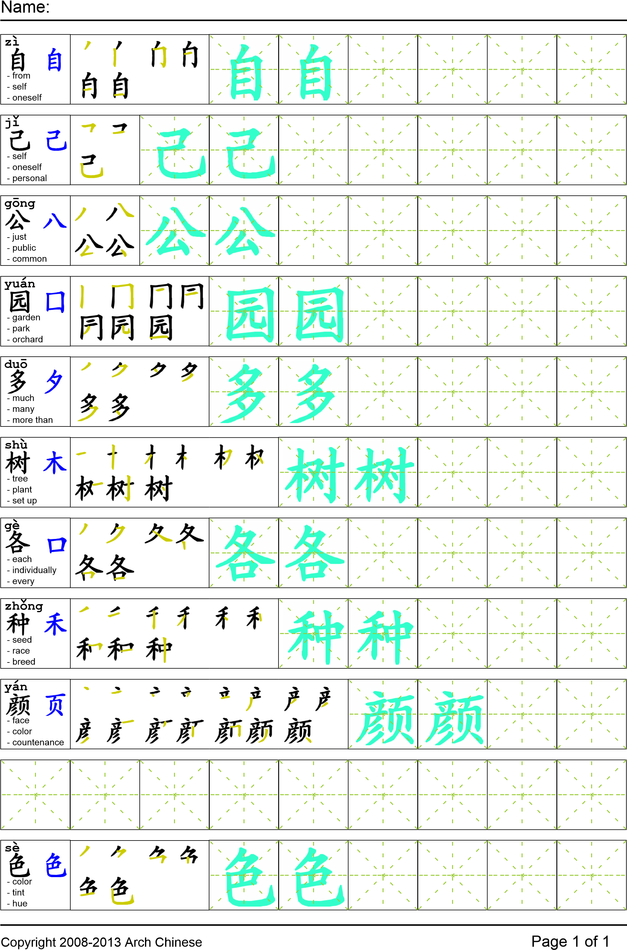
Reading

我自己去了公园。公园很漂亮有很多的树，也有各种颜色的花。我最喜欢的地方是公园里的一条河。我喜欢这个地方因为这里的环境很平静。坐在河的旁边我开始想谁是小偷？为什么把东西放在我的家？为什么都是小孩的书？
Task Completion

Once all tasks are complete turn the assignment in to collect the points for the project.
Task 1: Trace the vocabulary and copy the text into the notebook.

Task 2: Answer Comprehension Questions.

Task 3: Write the Pinyin for the Reading.

Task 4: Translate the Reading into English.

Task 5: Record yourself reading the passage.

Comprehension Questions
- What are the two main meanings of 想？which one is used in this reading? _________________
- Why does the author like the park? _________________________________________________
- What does 边 mean? ____________________________________________________________
- What question words do you know? ________________________________________________

